**CN LAB 5 REPORT**

**Experiment Overview:**

* To configure Network Address Translation (NAT) on a router using Cisco Packet Tracer
* To demonstrate the setup and configuration of NAT to allow internal network devices to communicate with external networks.

**Steps taken to set up the network**

**Step 1:**

Drag and drop required Network devices (2 Router-PT's and 1 Switch-PT) and End devices (2 PC-PT's and a Server-PT) as shown below.

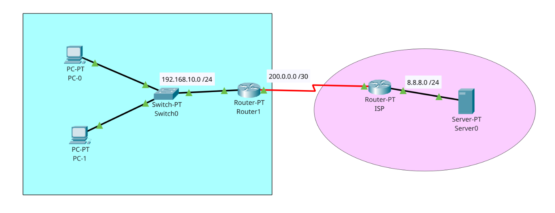

**Step 2:**

Open each Router and navigate to physical tab, and add PT-ROUTER-NM-1CGE, PT-ROUTER-NM-1S, PT-ROUTER-NM-1FFE Modules to the Router1 and add the same modules as Router1 except for PT-ROUTER-NM-1FFE, add PT-ROUTER-NM-1CGE module.

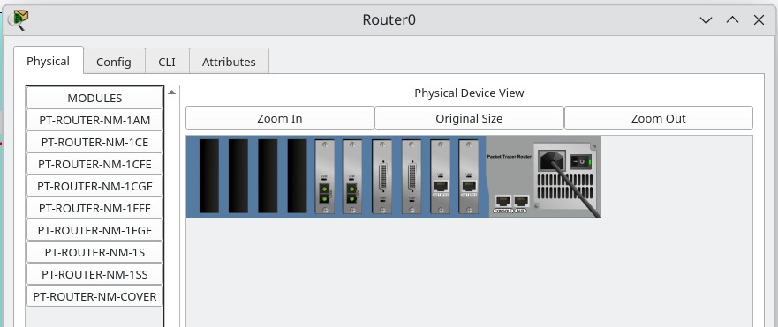

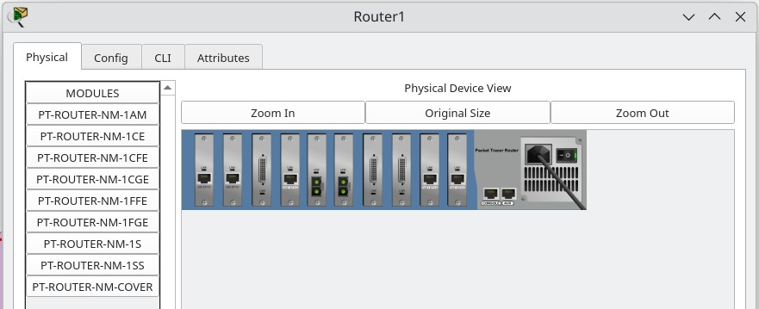

**Step 3:**

Make connections using cables between all the devices as shown in the picture.

Use Copper Straight through cable to connect different devices and use a Serial DCE cable to connect ISP Router and Router 1.

**Step 4:**

Now, Configure IP address of the routers and end devices according to the configuration table below.

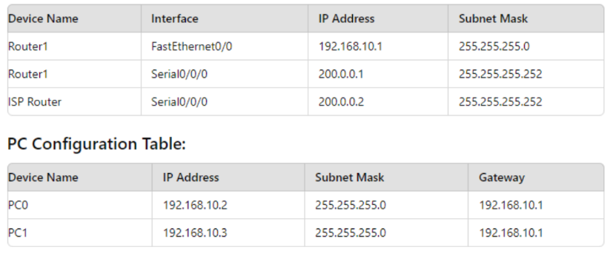

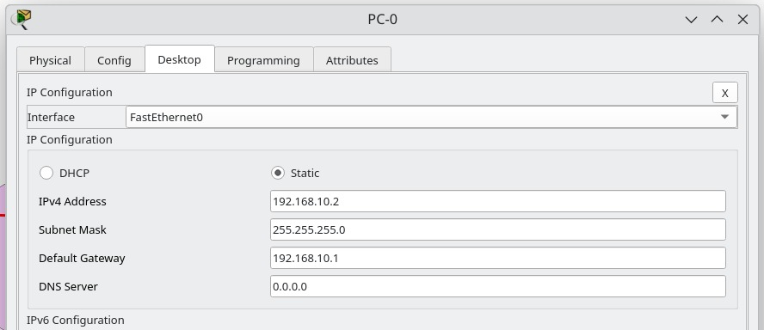

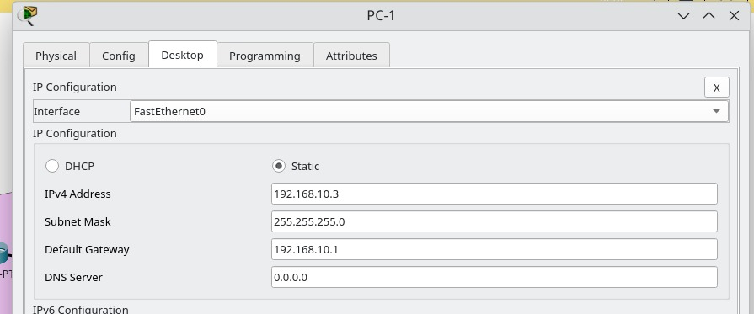

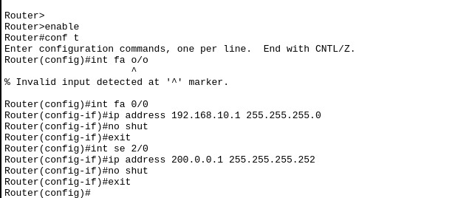

Router1

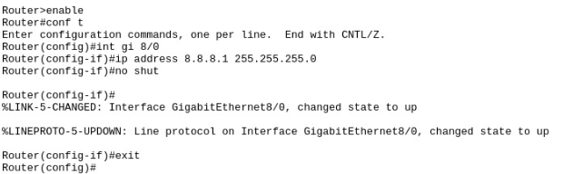

ISP Router

And configure the Ip address of the server as

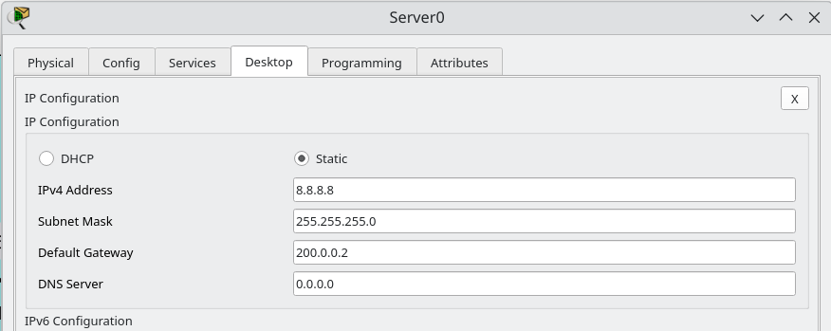

**Step 5:**

We shall enable ospf routing protocol between both routers.

In Router 1

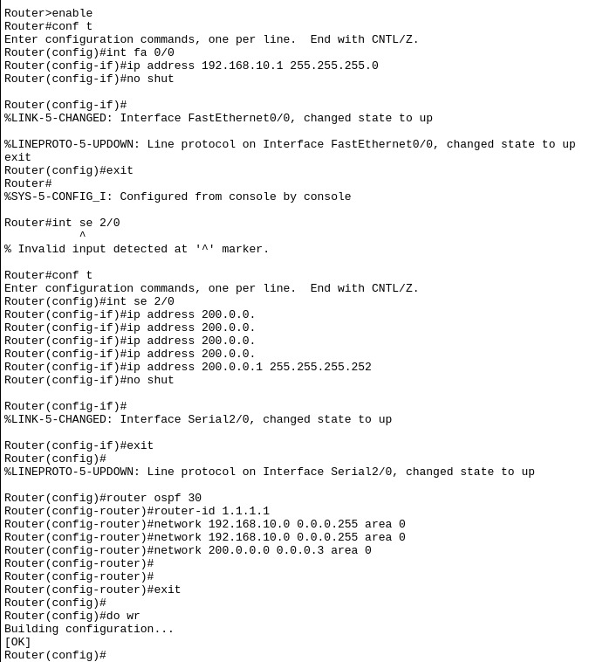

In ISP router;

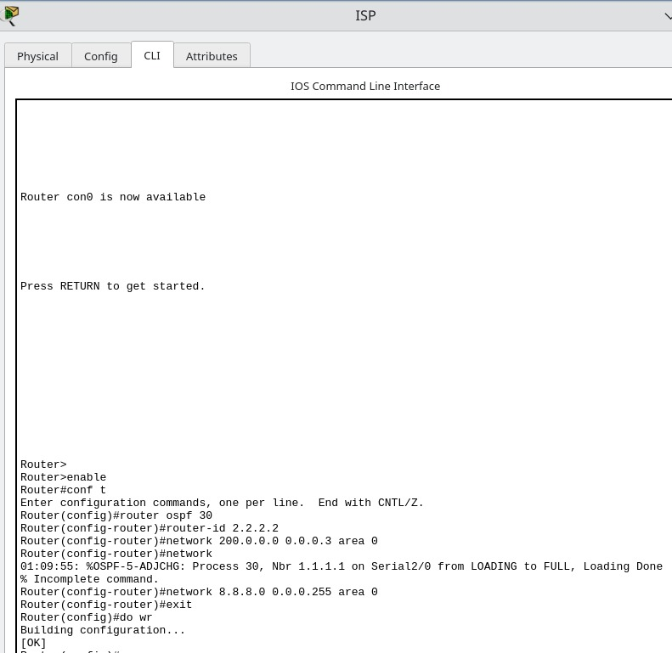

**Step 6:**

Ping Server (8.8.8.8) from PC-1

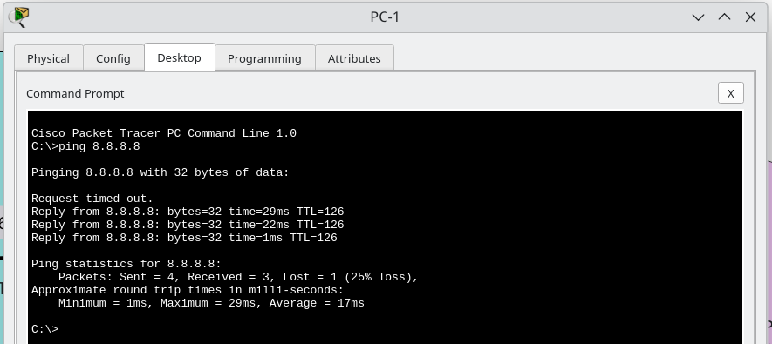

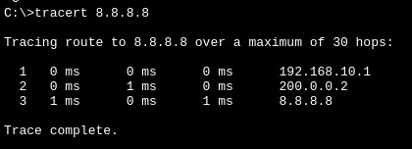

**Step 7:** Check for Address Translation

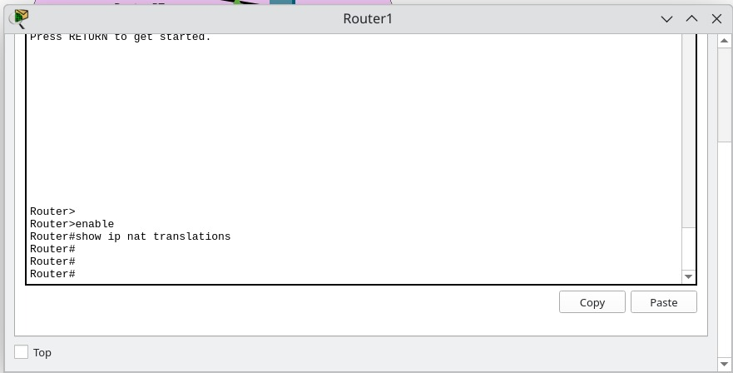

**Step 8:**

Configure Static NAT and configure interfaces as NAT inside and outside.

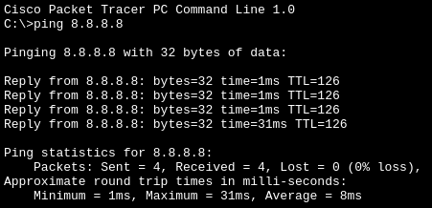

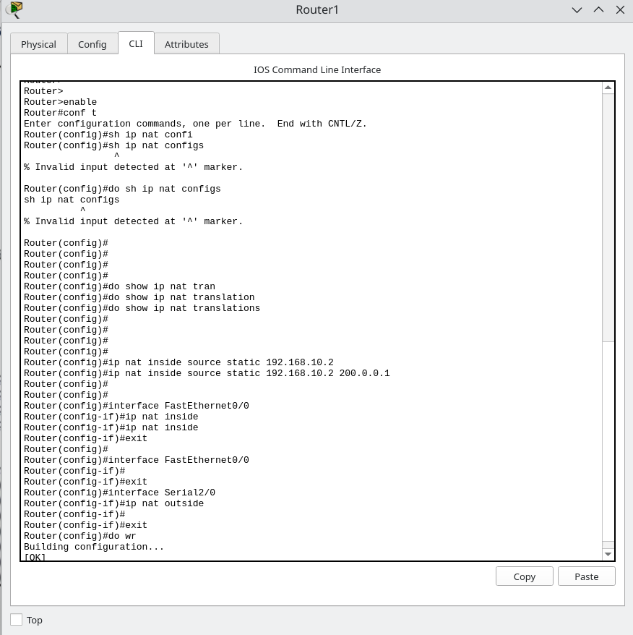

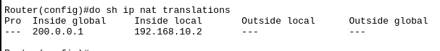

Now, let us ping again and verify the NAT

In Router1

